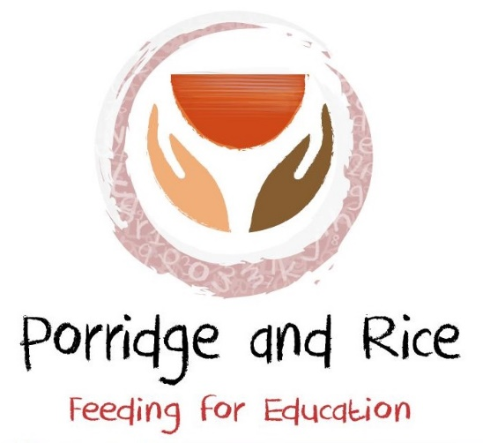
Porridge and Rice’s mission statement on HIV
The charity “Porridge and Rice” does not discriminate against any individual with a positive HIV status; neither does it discriminate against their children or family. HIV continues to be a devastating disease and awareness of an individual’s status can help reduce the spread of the virus. With the advancement of medicine, the chance of living a full, healthy and happy life is higher today than ever before.
There continues to be widespread research into cures for HIV but one has not been found yet. Current treatment involves combinations of anti-HIV (antiretroviral) drugs, which stop the virus from reproducing, thus allowing the immune system to strengthen and fight infection. To get the most benefit from HIV treatment, it must be taken as prescribed (to a regular schedule). The charity does not believe that any individual should feel shame if they are diagnosed with the disease. All staff at Porridge and Rice schools are encouraged to be tested: this is not so that they are discriminated against or treated differently, but so that they can be supported in getting the right treatment. The greater the level of support, the more likely people are to adhere to a treatment programme and live a longer, healthier life.
Porridge and Rice also recognises that with the right treatment and care during pregnancy and birth, and by not breastfeeding, it’s possible to prevent mother-to-child transmission of HIV.
Porridge and Rice reminds all its members that HIV cannot be spread by kissing, hugging, shaking hands, or any other normal social contact with somebody with HIV. Nor can HIV be contracted by being near someone with HIV, sharing household items such as crockery, cutlery, or bed linen. HIV cannot be passed on by spitting, sneezing, or coughing on another person.
Condoms provide the best protection against HIV and other sexually transmitted infections when used properly during sexual intercourse. Individuals can have a long-term relationship and a fulfilling sex life with a partner who is HIV positive and stay HIV free. It’s completely safe to kiss and hug a partner with HIV. Using condoms is a very effective way of preventing HIV transmission during sex.
Porridge and Rice encourages all its HIV-positive members to attend regular monitoring to check that treatment is working. Any staff member whose status is HIV-positive is given time to attend clinic without having their pay docked. Looking after physical and mental health and general well-being is a good basis for treatment. All members are encouraged to get enough sleep, eat a healthy diet, exercise, not smoke, and not drink excessive amounts of alcohol. Mental health and emotional wellbeing also play a part in staying well: depression and anxiety are common problems - acknowledging feelings and finding support to deal with concerns or mental health issues is encouraged.
Any HIV-positive child is welcomed to the school. We encourage everyone to be accepting and open to receiving pupils and staff with any medical condition.

